|  |  |  |
| --- | --- | --- |
| CDR | April 25  2016 | |
|  | | Critical Design Review |

|  |  |  |  |
| --- | --- | --- | --- |
| **Revision record** | | | |
| Version | Date | Attendees | Comment |
| 1.0.0 | 25.04.16 | Arshad Shakil,  Badis Madani,  [Håkon Hedlund](https://www.facebook.com/hakon.hedlund)**,**  Zhili Shao |  |
| 1.0.1 | 02.05.16 | Badis Madani |  |

Contents

1. Introduction 3

2. The System Overveiw 3

3. The System Components 3

3.1 STM32F103 microcontroller 3

3.2 The 7-inch Touchscreen 4

3.3 The 4-Channel Relay Module 7

3.4 DHT11 Humidity-Temperature Sensor 8

3.5 Temperature Sensor (DS18B20) 9

3.6 MH-Z14 CO2 Module 10

3.7 HC-SR501 PIR Motion Detector 11

4. System Block Diagram 13

5. Reference 13

# Introduction

This document will include a detailed description of the subsystems of the HVAC control system (Control Panel) along with technical specifications and features. In addition, it includes all supporting analyses that were carried out to validate the design. The technical budgets will be provided. In addition, it also outlines the financial budget to indicate that funding is available to finish building, testing, launching

# The System Overveiw

The HVAC control system, which is a Control panel will be used for setting the value of temperature, humidity, CO2 level they prefer through this panel. Sensors, which are assembled in one specific closed space like office or classroom, will collect the indoor environment data (temperature, relative humidity, C02 level) and translate them to the controller inside the panel. After calculating the regulation data and sensor data, the adjusting data will be created and translated to actuators like motors, valves, and dampers of HVAC system to change the indoor environment.

In the next part, the control system components will be presented with a description, specification and features of each.

# The System Components

The components used in this design are all COTS (Commercial of the shelf). They will be purchased from the respective vendor, and assembled to make the system. The components chosen are:

* STM32F103 Microcontroller
* ER-TFT070-4 7 inch TFT LCD touchscreen
* ESP8266 WiFi Module
* 5V 4-Channel Relay interface board
* DHT11 digital temperature and humidity sensor
* DS18B20 digital thermometer
* MH-Z14 NDIR Infrared CO2 sensor
* HCSR501 PIR motion detector

## 3.1 STM32F103 microcontroller

The STM32F103 Microcontroller is produced by ST Company. It has many high level features in compare of other microcontrollers. It is one of the best in class 32 bit microcontrollers, best performance to control and connectivity in electronics projects, it is able to perform in DSP (Digital Signal Processor) solutions (High frequency performance), has low power application in order to save power for system, the speed of peripheral is increased for the better performance etc.

It is suitable for a wide range of applications such as motor drives, application control, medical and handheld equipment, PC and gaming peripherals, GPS platforms, industrial applications, PLCs, inverters, printers, scanners, alarm systems video intercom, and HVAC.

**Features:**

* Includes ST Microelectronics STM32F103 High-Performance Microcontroller with 128kBytes of Memory.
* Microcontroller features 32-Bit ARM Cortex-M3 Processor running up to 72MHz.
* Direct Full-Speed USB Computer Connection (USB 2.0 Compliant).
* Fully Assembled and Ready to Run.
* SD Card Socket.
* 1 Variable Trimpot for Adjustable Analogue Input.
* 8 Red Test LED's.
* Real Time Clock with Battery Backup.
* JTAG Connector.
* LCD Connector with Contrast Adjustment.
* 2 USART's for RS232 Connection and Program Download.
* Power and Boot LED.
* Boot and Reset Pushbutton

## 3.2 The 7-inch Touchscreen

For the HVAC control system we have chosen a 7 inch TFT LCD module which is capacitive. The model is ER-TFT070-4 from Eastrising technology which is based in China.

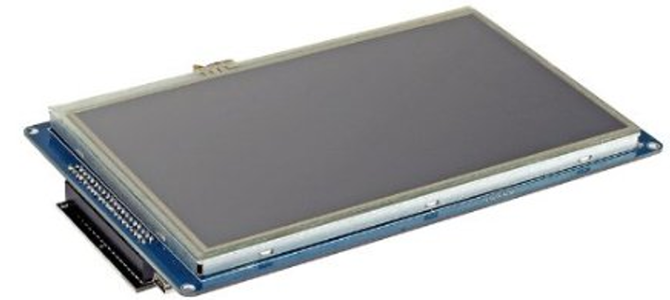

When it comes to the display properties of the model, it runs on an 800x480 resolution. It also has support for up to 256k colors. It has a 20ms response time, and its viewing angle range is up to 60 degrees from all four sides. It has support for I2C and SPI which makes it good for connecting to a micro controller unit. It also has support to 3.3V and 5V which makes it very versatile. This specification is applied to the 7 inch WVGA supported TFT-LCD module, and can display true 262,144 colors(6 bit/ color). The module is designed for OA, Car TV application and other electronic products which require flat panel display of digital signal interface. This module is composed of a 7”TFT-LCD panel, a driver circuit and LED backlight unit and used as the input devices for general electric appliances via both finger and pen-entry.  
When it comes to cost it’s not very expensive either. The price ranges from 35 USD to 30 USD depending on how many units you order. These specifications fit well into our proposed design concept and the pricing makes it very attractive. Below you can see the full specifications of the LCD display:

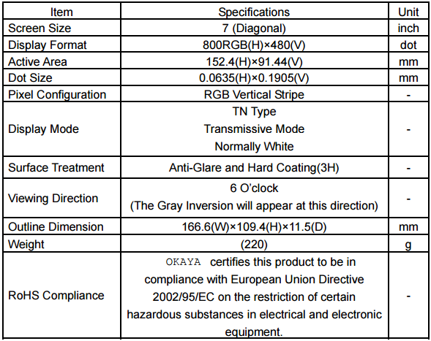**Specification:**

**Features:**

- WVGA (800×480 pixels) resolution.

- Digital 18 bit parallel RGB. - Dot inversion mode with stripe type.

- Transparent Touch panel

* 4-Wire
* Analog Resistive

## 3.3 The 4-Channel Relay Module



This is a 5V 4-Channel Relay interface board, able to control various appliances, and other equipments with large current. It can be controlled directly by a wide range of microcontrollers such as[Raspberry Pi](https://github.com/fixedd/RPi_SainSmart_Interface#readme), Arduino, 8051, AVR, PIC, DSP, ARM, ARM, MSP430, TTL logic.

* 5V 4-Channel Relay interface board, and each one needs 15-20mA Driver Current
* Equipped with high-current relay, AC250V 10A; DC30V 10A
* Standard interface that can be controlled directly by microcontroller (Arduino , 8051, AVR, PIC, DSP, ARM, ARM, MSP430, TTL logic active low)
* Opto-isolated inputs
* Indication LED’s for Relay output status

## 3.4 DHT11 Humidity-Temperature Sensor



DHT11 digital temperature and humidity sensor is a composite sensor that contains a calibrated digital signal output of the temperature and humidity. Application of a dedicated digital modules collection technology and the temperature and humidity sensing technology, to ensure that the product has high reliability and excellent long-term stability. The sensor includes a resistive sense of wet components and an NTC (Negative temperature coefficient) temperature measurement devices, and connected with a high-performance 8-bit microcontroller.

**Specification:**

- Humidity measuring range: 20% ~ 90% RH (0-50° C temperature compensation)  
- Temperature measuring range: 0 ~ +50°C  
- Humidity measuring accuracy: 5.0% RH  
- Temperature measurement accuracy: 2.0 C  
- Response time: (Updated by Rob Tillaart: now < 50 ms)  
- Low power consumption  
Features:  
- Single wire digital interface ( the most simple system integration, ultra-low prices )  
- Ultra-small size ( 12X15.5X5.5 mm )  
- High reliability  
- Optimized long-term stability

## 3.5 Temperature Sensor (DS18B20)



This is a highly accurate and reliable temperature sensor for the Raspberry Pi. The DS18B20 digital thermometer provides 9-bit to 12-bit Celsius temperature measurements and has an alarm function with nonvolatile user-programmable upper and lower trigger points. The DS18B20 communicates over a 1-Wire bus that by definition requires only one data line (and ground) for communication with a central microprocessor. It has an operating temperature range of -55°C to +125°C and is accurate to ±0.5°C over the range of -10°C to +85°C. In addition, the DS18B20 can derive power directly from the data line ("parasite power"), eliminating the need for an external power supply.

**Features:**

* Unique 1-Wire® Interface Requires Only One Port Pin for Communication
* Each Device has a Unique 64-Bit Serial Code Stored in an On-Board ROM
* Multidrop Capability Simplifies Distributed Temperature-Sensing Applications
* Requires No External Components
* Can Be Powered from Data Line; Power Supply Range is 3.0V to 5.5V
* Measures Temperatures from -55°C to +125°C (-67°F to +257°F)
* 0.5°C Accuracy from -10°C to +85°C
* Thermometer Resolution is User Selectable from 9 to 12 Bits
* Converts Temperature to 12-Bit Digital Word in 750ms (Max)

## 3.6 MH-Z14 CO2 Module

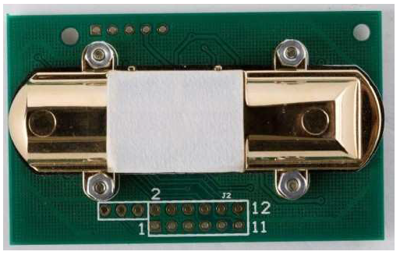

For [HVAC](https://en.wikipedia.org/wiki/HVAC) applications, CO2 sensors can be used to monitor the quality of air and the tailored need for fresh air, respectively. Measuring CO2 levels indirectly determines how many people are in a room, and ventilation can be adjusted accordingly.

MH-Z14 NDIR Infrared gas module is a common type, small size sensor, using non-dispersive infrared (NDIR) principle to detect the existence of CO2 in the air, with good selectivity, non-oxygen dependent, long life. Built-in temperature sensor can do temperature compensation; and it has digital output and analog voltage output. MH-Z14 NDIR Infrared gas module is applied in the HVAC, indoor air quality monitoring, industrial process, safety and protection monitoring.

**Specification:**

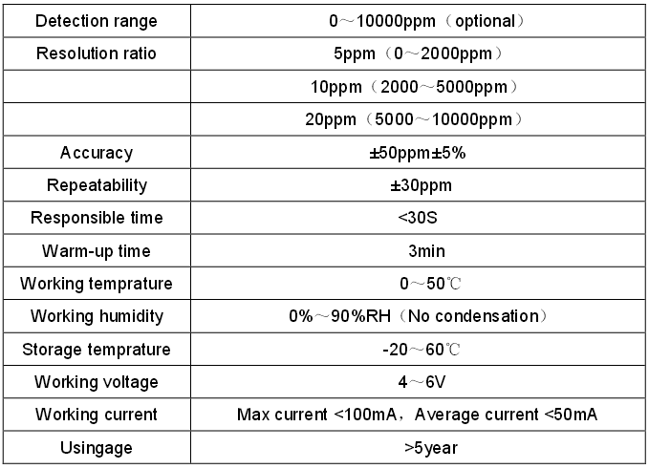

## 3.7 HC-SR501 PIR Motion Detector



PIR sensors allow you to sense motion, almost always used to detect whether a human has moved in or out of the sensors range. They are small, inexpensive, low-power, easy to use and don't wear out. For that reason, they are commonly found in appliances and gadgets used in homes or businesses. They are often referred to as PIR, "Passive Infrared", "Pyroelectric", or "IR motion" sensors

**Specification:**

* Use BISS0001 signal processing IC, sanyo genius regulator
* Voltage: 5V – 20V
* Power Consumption: 65mA
* TTL output: 3.3V, 0V
* Delay time: adjustable (0.3 sec – 10 minutes)
* Lock time: 0.2 sec
* Trigger methods: L – disable repeat trigger, H enable repeat trigger
* Sensing range: less than 120 degrees, within 7 meters
* Temperature: – 15 ~ +70
* Dimension: 32*24 mm, distance between screw 28mm, M2, Lens dimension in diameter: 23mm

**Features:**

* Automatic detecting: the output will be high when objects enter the sensing range, and automatically turn to low when object leave
* Photosensitive control (optional, not factory-set yet) can be set.
* Temperature compensation (optional, factory reset): In the summer when the ambient temperature rises to 30 ° C to 32 ° C, the detection distance is slightly shorter, temperature compensation can be used for performance compensation.
* Working mode (set by jumper)
  + **Non-repeatable trigger/ delay mode (set to LOW)**: the sensor will turn to low TTL after the delay, even the sensing object is still in range.
  + **Repeatable trigger (set to HIGH)**: the sensor will not turn to low if the object still staty in the sensing range in the delay time.
* Wide operating voltage range: default voltage DC4.5V-20V.
* Micro-amp power level consumption: static current <50 microamps, particularly suitable for battery-powered automatic control products.
* Output high signal: easy to achieve docking with the various types of circuit.

# System Block Diagram



# Reference

<https://www.qb50.eu/index.php/design-review/cdr>

<http://contractingbusiness.com/iaq-amp-ventilation/humidity-control-knowledge-power>

https://arduino-info.wikispaces.com/DHT11-Humidity-TempSensor

<http://akizukidenshi.com/download/ds/aosong/DHT11.pdf>

<https://www.futurlec.com/Datasheet/Sensor/MH-Z14.pdf>

<https://www.mpja.com/download/31227sc.pdf>

<http://www.electrodragon.com/product/pir/>

<http://www.espruino.com/datasheets/STM32F103xC.pdf>

<http://www.futurlec.com/STM32_Development_Board.shtml>

<https://www.sparkfun.com/products/13678>

<https://www.embeddedarm.com/documentation/third-party/RV800480T-7X0WP-A3.pdf>

<http://rancidbacon.com/files/kiwicon8/ESP8266_WiFi_Module_Quick_Start_Guide_v_1.0.4.pdf>

<http://www.sainsmart.com/4-channel-5v-relay-module-for-pic-arm-avr-dsp-arduino-msp430-ttl-logic.html>

<http://ha.privateeyepi.com/store/index.php?route=product/product&product_id=63>